1. **TOTAL REVENUE :**

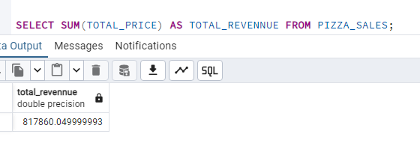

**2 AVERAGE ORDER VALUE :**

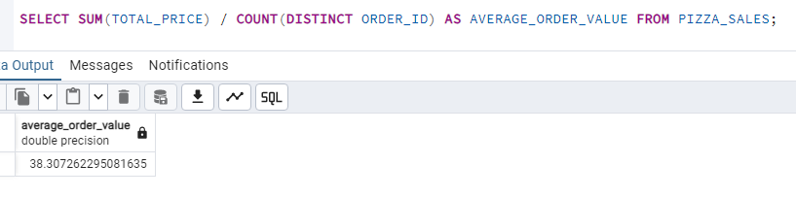

**3 TOTAL PIZZA SELL**

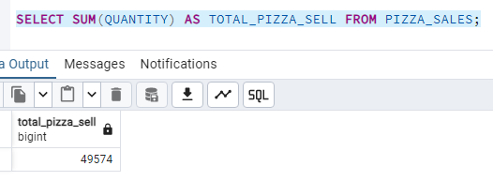

**4 TOTAL ORDERS**

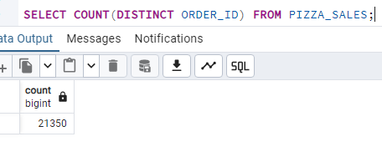

**5 AVERAGE PIZZA PER ORDER**

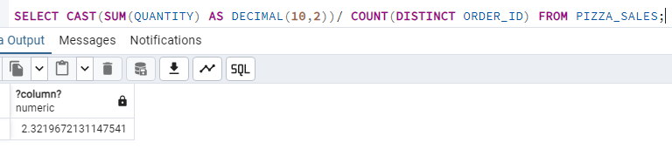

CHART REQUIREMENTS QUERIES

1. DAILY TREND FOR TOTAL ORDFERS

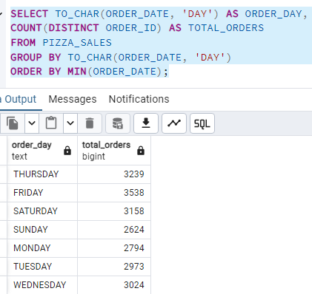

1. HOURLY TREND FOR TOTAL ORDERS

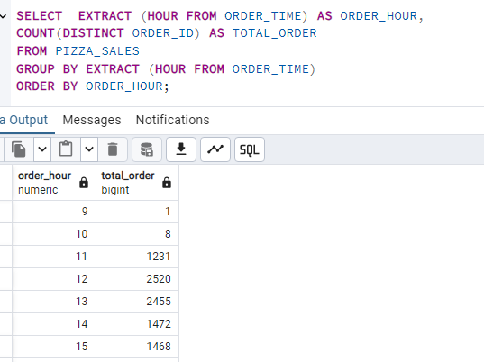

1. PERCENTAGE OF SALES BY PIZZA CATEGORY

